
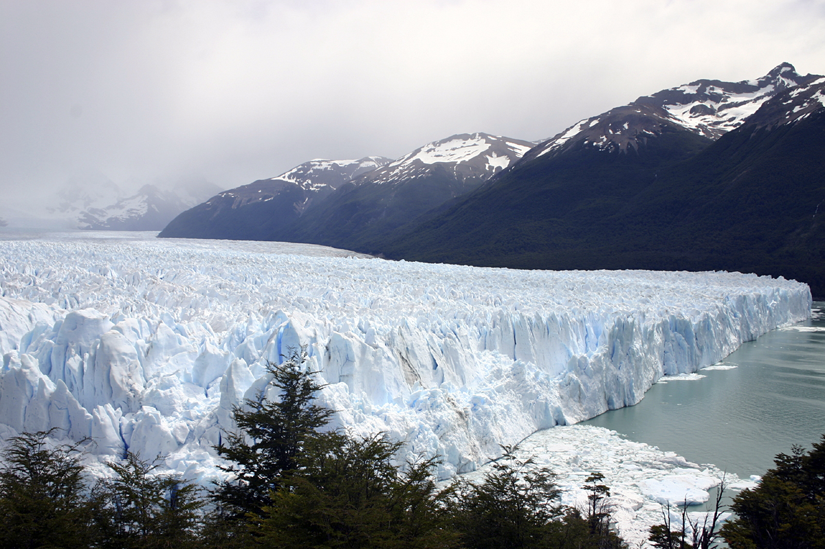
Winter Forest Lodge

Assignment 1: Research

Do a search on the state of Colorado. Select a city that you would like to place the resort, Winter Forest Lodge in. Gather basic info. about this city and include this information in your PowerPoint presentation, explained below.

Assignment 2: Research

You need to find out information about hotel chains to gather research for Winter Forest Lodge such as size of rooms, costs, amenities, etc. Some of the major hotel chains you can research are: Hilton Inn, Holiday Inn, Radisson Hotel, Best Western Hotel and of course, others that you select. This information can be used for Assignments 5 and 6 (See below).

Assignment 3: Letterhead

You are going to design a letterhead today. Use clip art to show the “customer” what Winter Forest Lodge reflects – winter sports. Include the name Winter Forest Lodge, address, phone number, fax number, web URL – anything that someone wanting to stay at the Lodge would need for in order to get in contact with you. Remember your letterhead should not take up more than two inches at your top margin.

Assignment 4: Business Letter

You receive a letter from Ms. Jennie Smith, 1042 Reed Street, Bat Cave, NC 28710. Ms. Smith wants to have a great week somewhere in Colorado. Send her a letter (see pg. 77 for an example) (on the letterhead you designed) and convince her that Winter Forest Lodge is the place for her to come. Ms. Smith is a busy executive that needs a week of rest so make sure your letter reflects “rest and relaxation”.

Assignment 5: Excel Spreadsheet

Create an Excel Spreadsheet reflecting your research on hotels. Create an organized data sheet which includes your listing of room types, amenities, room rates, rating (3-4-5 star) tax, and total cost, etc. Create a pie chart with data labels (value). Your pie chart should include the name of the hotel with total cost (including the tax). Be sure to show on your datasheet the min and max values for hotels.

Assignment 6: PowerPoint Presentation

Your supervisor has asked you to make a PowerPoint presentation that can be used to advertise Winter Forest Lodge. The Lodge wants to make sure the National Security and Crime Prevention Committee who is looking at your Lodge for a possible convention will select Winter Forest Lodge. List the attractions of the Winter Forest Lodge. Six slides will be appropriate. Don’t be too fancy as you don’t want the NSCP Committee to be distracted. Remember your 11 Commandments of PowerPoint. Select a theme and also include some of the leisure time activities guests may participate in after convention meetings –skiing, snowboarding, something to do with the winter season.

Assignment 7: Menu

Winter Forest Lodge has an awesome restaurant. The manager has called you to set up a menu for the special events dinner to be held December 22. Use an 8.5 x 11 sheet of paper and design a menu. Make the format appealing. Would clip art be useful? Think about your experiences in eating in restaurants. What appeals to you? Create your own prices for each item. You will need to use these foods on this assignment:
Menu
Caesar Salad * Garden Salad * Pasta Salad * Fruit Cocktail

Leg of Lamb * Grilled Salmon * Chicken Cordon Blue * Steak & Shrimp * Angel Hair Pasta with Vegetables

Strawberry Shortcake * Triple Chocolate Cake * Custard * Pumpkin Pie * Blueberry Pie
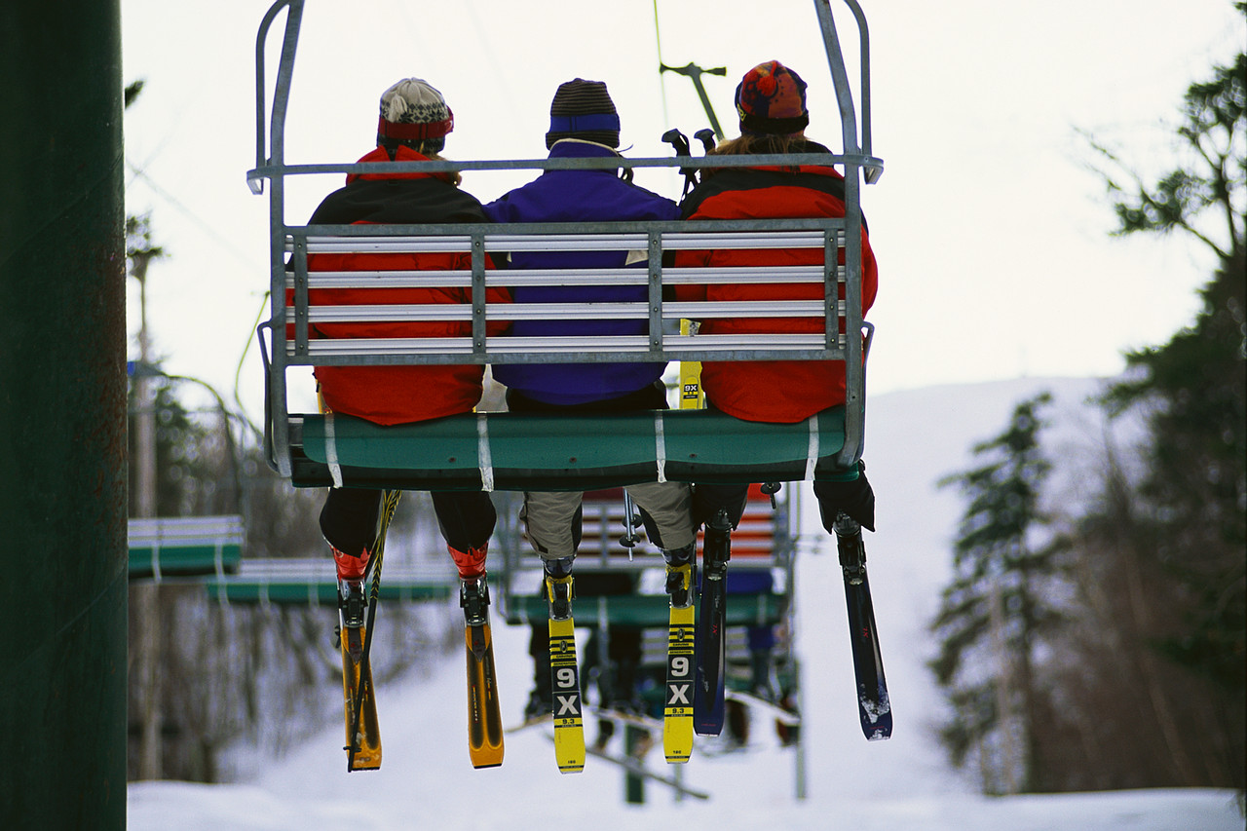

Coffee * Tea * Milk * Soda (List varieties)
Winter Forest Lodge
Colorado

