Tutorial G1 Inserting Clip Art & Photos (19points)
- What graphic elements can you include in your Publisher document (list 2)?
- Which tab should you select in order to access ClipArt?
- To insert a picture from a _______________, select the ________________ button, locate your picture, and select ______________.

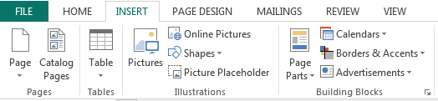
- Please circle the Picture button below:
- Once the Picture Tools tab becomes available, what can you do to your picture? (list 3)
- Please circle where you can change a picture’s brightness, contrast, or recolor.
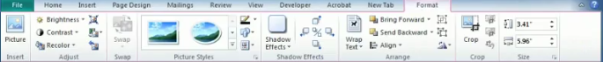

- There are three more picture editing options mentioned…what are they?

- Please circle the Picture Styles area, Shadow Effects, and Crop buttons below. (3)
- ClipArt are _______________ pictures that are stored that you can use in your document.

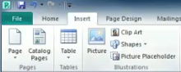
- Please circle the ClipArt button below:

