Tutorial F1 Using Cut, Copy & Paste (7 points)
- How many options do you have when cutting information?

- What are the options for cutting text?

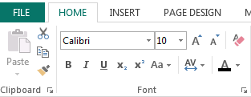
- Please circle the cut tool below:

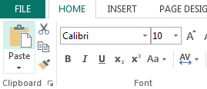
Please circle the paste tool below:

- Please circle the copy tool below:

- All these options are available as well be using the ___________________ click.
Shortcut for paste!

Shortcut for copy!

