Tutorial E7 Using Character Spacing (17points)

- One way you can make your text stand out is through using __________________ spacing.

- What character spacing will do, is either __________________ out your text or condense your individual letters ______________________ to make that text __________________ out.

- Please circle the character spacing icon below:

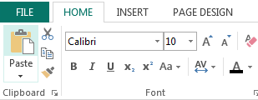

- What are the five character spacing options after clicking on the character spacing icon (very similar to how people wear their clothes!)?
1.
2.
3.
4.
5.
- If you select the “More Spacing” option, the character spacing dialog box appears. In here, you can _______________ or _________________ the text by more (percentage) or less (percentage).

- With character spacing, you can do more than just shrink or stretch the text. You can go into the ____________________ column to adjust spacing for the highlighted ______________ of text.

- You can also access character spacing by highlighting the text and _____________ clicking, go to ________________ text and select ___________________________ spacing.

Character spacing

