Tutorial E6 Working With Color Schemes (7 points)

- In Publisher, you have the option to change the color ___________________ to suit your individual likes.

- You can _______________ your new color scheme choice to decide if it fits your publication.

- At any point in time, if you are ________________________ with the scheme, you can go to your page __________________, go to the ______________ group, and select the drop down _______________, and you can decide on another theme.

- Circle the scheme group below:

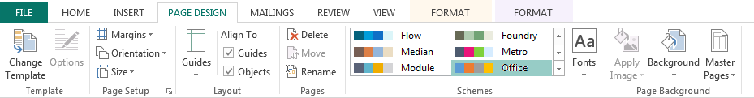

Tutorial E6 Working With Color Schemes (7 points)

- In Publisher, you have the option to change the color ___________________ to suit your individual likes.

- You can _______________ your new color scheme choice to decide if it fits your publication.

- At any point in time, if you are ________________________ with the scheme, you can go to your page __________________, go to the ______________ group, and select the drop down _______________, and you can decide on another theme.

- Circle the scheme group below:

