Tutorial E5 Coloring Fonts & Applying Fill Effects (10 points)

- In Publisher, you can font ______________ and add _________________ effects to your text.

- Please circle the font color icon below:
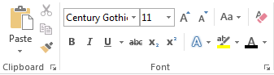

- You can click on the font color icon _________________ to see all your color options.

- If you go down, under the scheme colors and standard colors, you will see an option for ______________ colors.

- Here, you can choose from a standard _______________ or use the __________________ tool.

- Let’s say I want to add more than just color, go back to the font color icon, and select _____________ effects.

- This will help you decide if you want to keep the same color you chose, or maybe you prefer a different ____________________.

- What tool allow you to add other cool effects to your text?

