Tutorial G4 Using Building Blocks (16 points)
- Give two example of Building Blocks.

- Which tab must you click to access the Building Blocks group?

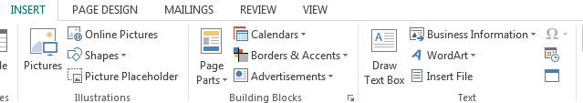
- Please circle the building blocks group below:
- In Page Parts, what options do you have (3 things)?

- If you select the bottom option, _____________ page parts, the ______________ block library dialog box appears.
- List two options you see in the building block library (after you select the more page parts option).

- What other interesting items can you add to your document (list 3)?

- If you select the arrow in the Building Blocks Group, the Building Block ____________________ appears, and you can _________________ from all the different building blocks.
