Tutorial G3 Using the Picture Style Gallery (13 points)
- The Picture Style Gallery allows you to add interesting ________________________ to your graphics.

- First, select the graphic you wish to ____________, the go to the _____________ tools tab.

- In the Picture Styles group, select the drop down _______________ for Picture Styles
Please circle that arrow below:
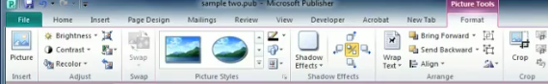

- Whenever you hover over the choices of picture styles, you can see a _______________ of it in your actual picture.

- What other interesting things can you do in the Pictures Gallery group? (list 3)

- What will a caption do to your picture?

- In the ribbon below, please circle the border button:
- In the ribbon below, please circle the caption button:
- In the ribbon below, please circle the shape button:

