Tutorial G2 Resizing Graphics (6 points)
- There are several ways to resize a graphic; you can simply select the little, white ___________ corners,
hold the ______________ key down, and ______________ the mouse to make it the right size.
- There are other ways to resize; I can go to my _______________________ tools, go to the
___________ group and adjust the size of the item.

- Please circle the size group below:
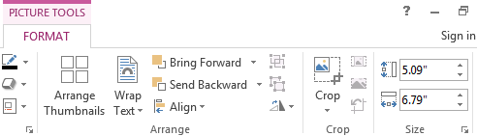

Tutorial G2 Resizing Graphics (6 points)
- There are several ways to resize a graphic; you can simply select the little, white ___________ corners,
hold the ______________ key down, and ______________ the mouse to make it the right size.
- There are other ways to resize; I can go to my _______________________ tools, go to the
___________ group and adjust the size of the item.

- Please circle the size group below:

