Tutorial F4 Using Find and Replace (18 points)
- What tab should you be on initially to access the Find feature?

- Next, go to the ____________ hand side of the ribbon and find the ________________ group. Now, go ahead and select the ________________ button. This will open up the _________________ and _______________________ pane.

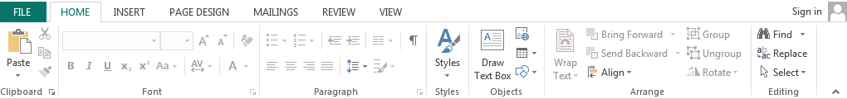
- Show me please where the Find button is below:
- Type in the “find ______________ box, the word you want the document to search for.

- After clicking the find ___________ button, you can find that word ___________________ your document.

- If you wish to ___________________ a word, you can do it in the pane or select the _____________ button.

- Please circle the find and replace buttons below:
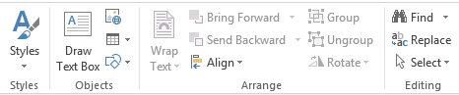

- When using replace, you will first tell Publisher what word you are looking for, and then you will tell Publisher what _________________ you want it replaced with. Click ______________ next.

- Publisher has found that word, now you can ___________________ that word, or you can decide to replace ____________, which means that anytime Publisher finds this word, it will __________________ it.

- Can you pick and choose which words Publisher replaces?

