Tutorial F2 Using Undo and Redo (5 points)
- Which toolbar do you go to access the Undo/Redo icons?

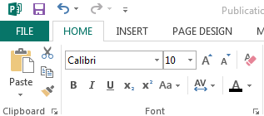
- Please circle the undo button below:

- Please circle the redo button below:

- Undo makes correcting basic _____________________ very easy in Publisher.

- Can you specifically change an action in the undo or redo list?

