Text Splash Ideas Starters!

- Poem
- Story
- Fairytale
- 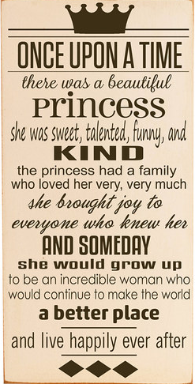Associations for your name
- Hobby (gardening, collecting, video games, shopping, crafting, etc.)
- Favorite band
- Favorite pastime
- Sport
- Goals
- A song
- Qualities/characteristics of a person
- Speech (Martin Luther King Jr.)
- Holiday traditions
- Family
- Tribute to someone famous or not famous
- College
- Childhood memories
- Mom, Dad, Grandma, Grandpa, etc.
- Brotherhood/sisterhood
- Game (Monopoly, Battle Ship, etc.)
- Technology (iPhone Apps, iPhone, etc.)
- Name brand
- Gifts to give others
- Popular boy/girl names
Directions:
- 8.5x11
- Create your text splash using different fonts, text direction, sizes, colors…
- Stay within your theme…connect all word associations!
- Check document for spelling
- Print

