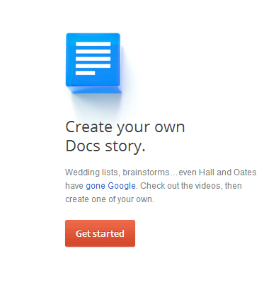
Google Story Binder
Go to this site:
http://docsstorybuilder.appspot.com/
Click Get Started
Add your characters of your story here:
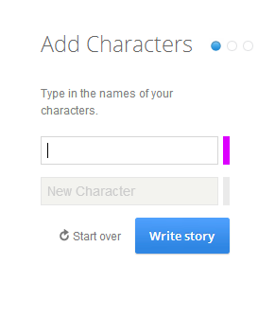
Click write story! Come up with something fun! Characters can be actors/actress, yourself/friends, cartoon characters, a teacher conversation, principals, etc.

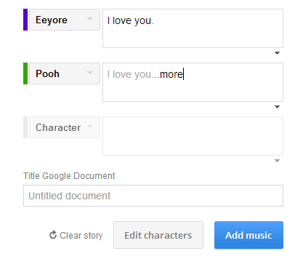
Now, add music to your story; there are lots of neat choices! Match the “mood” of your story to music!

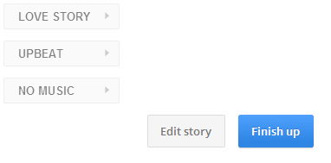
Now it’s time to Finish UP! Click here:

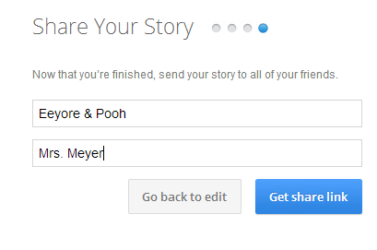
Give your story a title and put your name in the name box.

Now, click GET SHARE LINK!
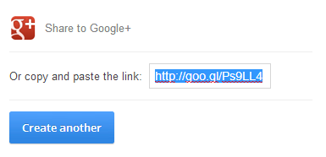
BE sure to copy the provided link!
Copy this think then paste it in an email to me, ameyer@portageps.org! I will share
it with the class! Appropriate stories PLEASE!!!!

