Career Cruising Name:
- Go to careercruising.com
- Login: ppsd-firstname.lastname
- Password: student id #
- Click Assessments
- Click Matchmaker and My Skills
- Click Start Matchmaker
- Name your session (Use your name perhaps Amy-Interests)
- Click Start Now
Take the assessment, when complete, look to the left; you should see at least 2 Career Pathway Recommendations. Write them here:

Look just below to see the Levels of Education: Record that here:

You can tailor your search by answering more questions; that is up to you! (Look to the left under, Improve My Results!
You have a Career Interest Rank; please list your top 5 career results below
1.
2.
3.
4.
5.
Click on your preferred career result.
Save this to your EDP (blue button in upper, right-hand corner)

This will show you how your interests connect with the job and what you may or may not enjoy; list a few observations here for me about these results.

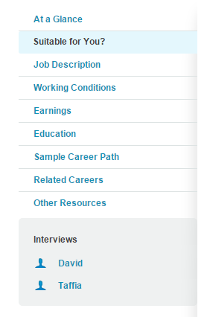
Job description: Tell me about the job in 3 statements:
1.

2.

3.

List 2 working conditions:

Show me the MONEY! What are the earnings for this career?
Entry:
Medium:
Experienced:

What level of education or training is required?

Now, be sure in the earnings area, to look at Michigan Outlook below all the MONEY! How many positions will be available in your career choice in the year 2020? If you prefer to live in a different state, note that you can select a different state in the drop-down box just below

Now, tell me about the level of education needed for this career.

Now, go to the Sample Career Path, look at the options and choose the path that makes most sense for you; write the steps in the path below.

Click on Related Careers; pick two related careers you might explore next.

You are all set! Turn in!

